x

 |  | 
 | 201289481 |  | 1062
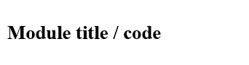 | GEOG5990M | 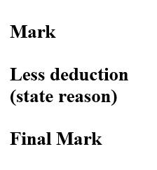
 | Independent Project


1.
2.
3.

Planning for Drunks Project Report

Outline of the Report
The report will be structured as follows:
- Introduction
- The intentions
- The though process
- Main Issues and solution
- Useful sources
- conclusion

- Introduction
This project will introduce a plan on how to guide drunken people to their home using algorithms in the framework file. Given the fact that drunks have a tendency losing sense of directions, this project aims to analyses their behaviours in the environment. This report will demonstrate the random movements of the drunks and the possibility of predicting their movements.

- The intentions in writing this:
The program was based on four elements which are the environment (the area of the study) the pub (the starting point), the drunks (Agents) who are the primary focus of the project and the houses (the ending point if the drunks entered their houses). The problem lies in connecting the four elements together and interacting with one another. For instance, how to set up houses as dictionary, how to create an agent and how to connect the agents with the ending point based on the dictionary. How to assign each agent with the ending point belonging

- The though process
To be able to write the code the first thing must be done is the good understanding for the description of the assessment and looking into the data provided. As in Geographical User Interface (GUI) assessment there are a similarity in this project. There are an agent and they represent the drunks and as a drunk’s behaviour they usually walk without being aware where they going to.

- Main Issues and solution:
To link the whole project with the raster file (drunk.plan) the resulted issued from the main issued can be illustrated as follows:

Issue A: Identifying the houses:
- Difficulty in identifying houses and locating them:
In order to identify the houses in the framework file, the issue was that houses are regions not just a single point on the environment map. (drunk.plan).
- Creating and connecting the houses with the agents:
The trouble here lies in creating the agents and linking them with the specified housed assigned to them.

Solution: Instead of list of points, I created a dictionary for it, the key in the dictionary specify the house number, and the value is a list of points that is in the house region. Following this method, I was able to locate the houses, I was also able to link agents with their houses. Thus, the agents were created based on the key of the dictionary.

Issue B: Locating the houses:
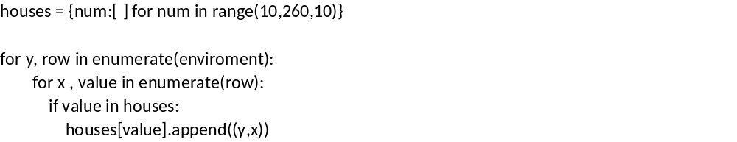
The problem was to identify if the value in from the environment is a value of house or just a background, and if it’s of house (e.g.: 10, 20, 30… 250) then its coordinate should be added to the list associated with same value in the houses dictionary.
Solution: the solution for this problem was by using “enumerate” function. This function was able to number the lines inside the environment list. Thus, identifying x and y enabling to locate houses.

Issue C: Unsolved problems:
- Colouring the pub:
The pub has the value of 1 which has no difference from the background which has 0 as a value. This difference in values resulted similar colours making it difficult to see the difference. Several attempts were done to overcome this issue, the first one was to add a costume colour for the value 1 on the map but I faced difficulties in achieving that. The second attempt was to change the value 1 to another value in the raster file (drunk.plan) yet this solution seemed to fabricate and falsifying the data .Therefore, I have gone for the solution to change the value to 100 using the coding in the module file. Yet it proposed the same idea of falsifying the data. So instead, I used a dot which specify the starting point (the pub) for the agents (drunks) and coloured it in red. Although this solution is not the ideal solution, but it works fine due to the limited assigned to the project. But the attempt to colour the bar showed me a problem that the animation is unstable, and this due to the codes must be reorganised and were on the codes as it is below:

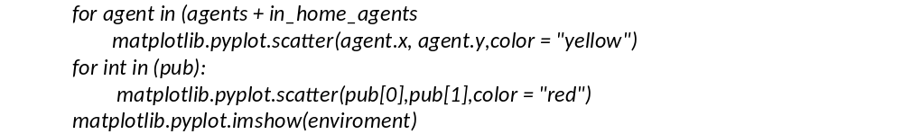
The following gif attachment might give better understanding about this issue:


In this way the bar is always on top and in order to make the point that represent the pub in the top of the background the animation and stop the background map from moving, the following code was used:

It can be said that the problem was solved, but not in the required manner.

- Helping the drunks to reach their houses faster:
There are some difficulty to find a way to help the drunks to reach their house faster by looking to some source to find how to build code on order to stop the to repeat or walk in the place the already walk in it and that can be if I have an advance skills in the programming.

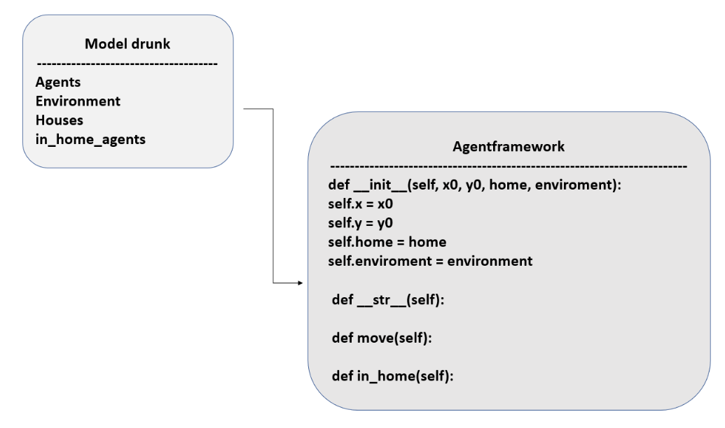
Figure 1 UML Diagram

- Useful sources
The following sources were helpful to give better understanding how the codes are used:
- https://www.geog.leeds.ac.uk/courses/computing/study/core-python/
This source was essential, to other sources.
- https://realpython.com/python-matplotlib-guide/
This source was used to give an idea to build graphics.
- https://docs.python.org/3/library/stdtypes.html#mapping-types-dict
This source provided a general overview about codes and how they are used.
- https://www.w3schools.com/python/ref_func_len.asp
This source helped in learning how to use the function (len).
- https://stackoverflow.com/questions/48797580/how-to-add-line-numbers-in-a-list
This source has been used to numbering the lines into the list.
- https://stackoverflow.com/questions/7370801/measure-time-elapsed-in-python
This source has been used to timed the codes.
- https://www.pythonforbeginners.com/dictionary/how-to-use-dictionaries-in-python/
https://developmentality.wordpress.com/2012/03/30/three-ways-of-creating- dictionaries-in-python/
https://www.programiz.com/python-programming/dictionary
These sources were very useful on building dictionary.

- conclusion
To conclude, anything in real life can be applicable in programming using equations describing human behaviours and attituded leading to solutions that could improve life quality. Furthermore, Python usage of open source data give a great freedom to build modules without any restrictions whatsoever unlike GIS programs which have some degree of limitation. The limitations of the project were encountered when building dictionary and build an algorithm allowing the agents to reach their houses faster and the possibility to apply that in real life.

